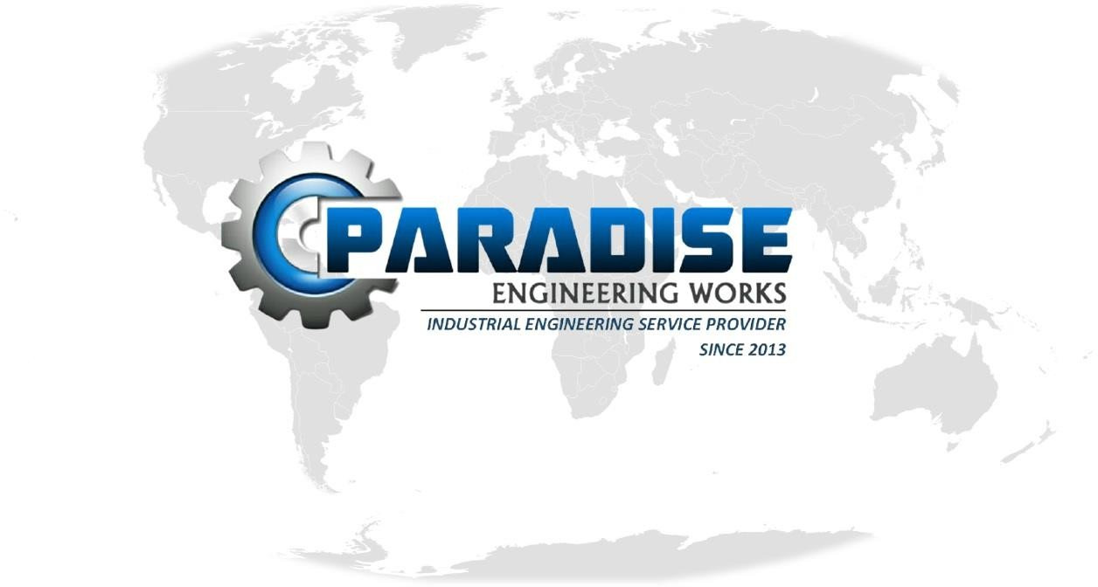COMPANY ADDRESS :
D-10,MIDC,SatpurI/F of Santosh Hotel, Nashik-422007.
CONTACT :
8329855767 / 9423964348.
EMAIL ID :
info@paradiseengg.com Paradiseengg.2013@gmail.com
WEBSITE :
www.paradiseengg.com





PARADISE ENGINEERING WORKS is incorporated in the year 2013 with one of India’s fastest growing Product design & development & Engineering Service Provider company.

Over the past Eight years PARADISE, is a safest company & has become a trusted business leader by providing exceptional expertise, technical knowledge and maintaining safety standards across every phase of the project. Clients rely on PARADISE to deliver world class service such as from the Engineering of Complex technical works (Like Industrial fabrication, Crane Manufacturing , SPM (Special Purpose Machines) as per client requirements, Agricultural & Pharmaceutical based products, Material handling & Storage Equipments etc. to Engineering Projects.

PARADISE has primary objective to be a Prominent Product development Company; recognized for business innovations and focused on total satisfaction and enhanced value creation for all its Customers.



“To be the perfect solution provider” for
customer requirements.
“Our mission is to satisfy customers with high quality products that enhances customer’s productivity by increasing the efficiency, flexibility, reliability and safety in their applications through continuous improvement of existing products & product customization.”




- New Product design & development
- Special purpose Machine Manufacturing
- Industrial fabrication Expert.
- Construction Tools part Manufacturing.
- Agricultural Sprayers Chassis manufacturer
- Pharmaceutical Products manufacturer
- Material Handling Equipment Manufacturer
☑Crane manufacturing
☑Oil Packaging service provider

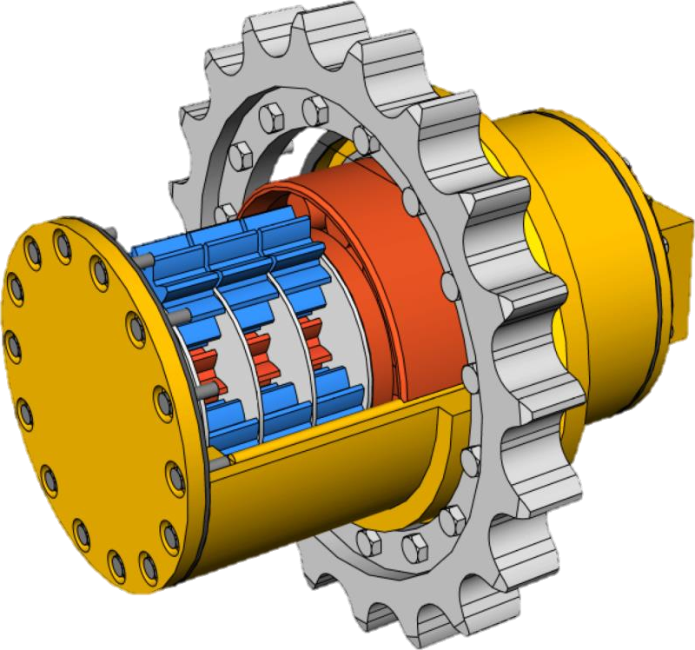
- Machine component design
- Fabrication structure design
- Reverse engineering of component
- Crane Design & development
- Design and development of plastic as well as sheet metal parts.
- Welding Fixture Development
- Customized Material Trolley manufacturer
- Creative Problem Solver in System.
- Customized Workstation design
- Production line throughput time decrease

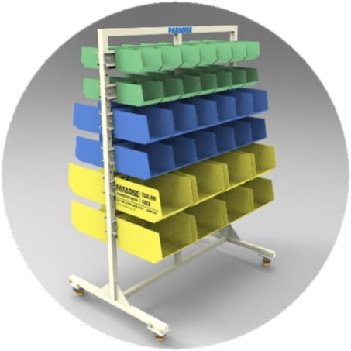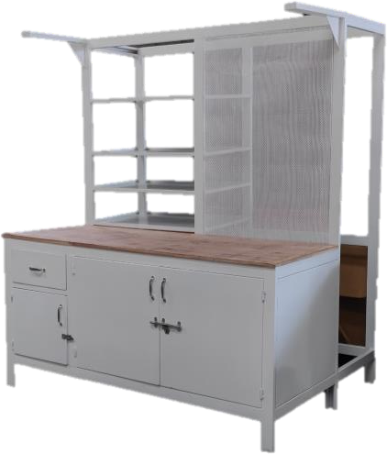

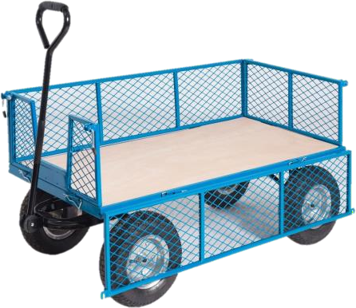
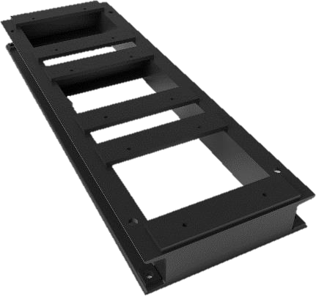
High Quality Pump/Motor base Frame High Quality Hardware Racks &Storage Solutions
Workstation manufacturing

Heavy duty Material Handling trolley
(Paradise Commercial Product)
( Client- Teknocrats, Nashik
( Client- Teknocrat,Sipra,Adhoc,FAB,IAC,Nashik)
(Client-Husqverna Group, Nashik)

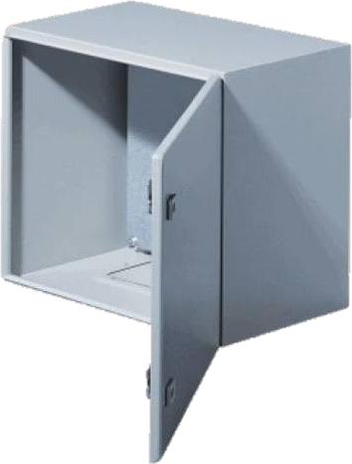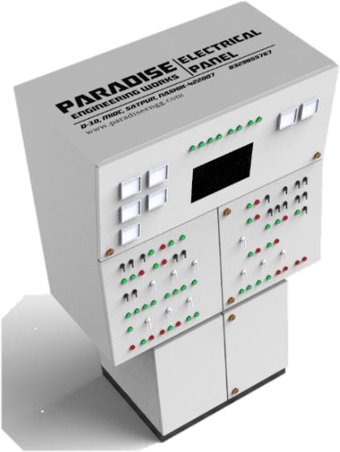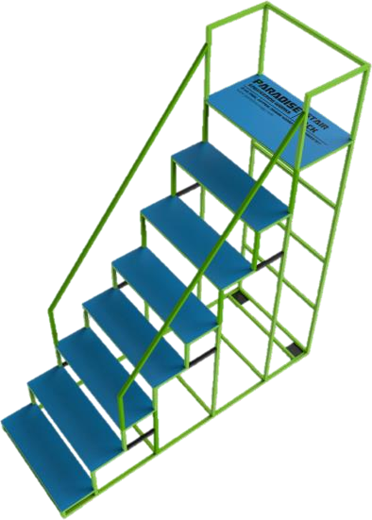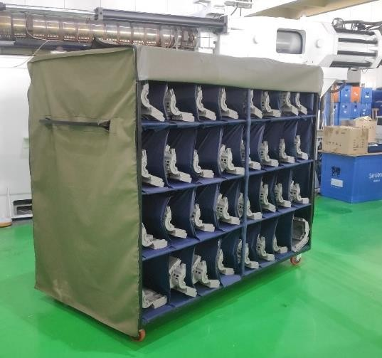

Electrical Panel Design, Development & manufacturing (Client- Adhoc,Nashik)
Industrial Roller Ladder
(Client-Husqverna Group, Nashik)
Industrial Material handling Trolley for Plastic products (Client- Virtuoso Opto Electric Pvt.Ltd,Ozar,Nashik)

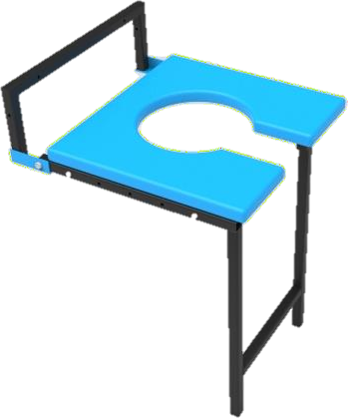
- Wall mounted Commode Chair
- Adjustable type seating arrangement.
- Color : Paint/Powder Coated
- Material : MS/SS304/Plastic
  - Walker
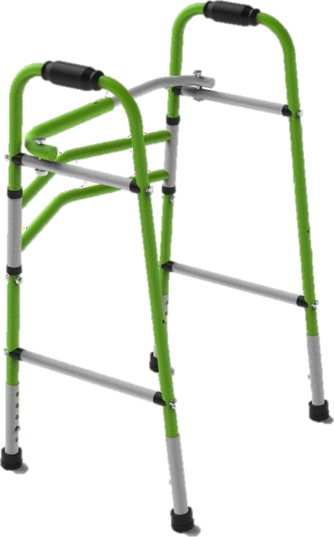
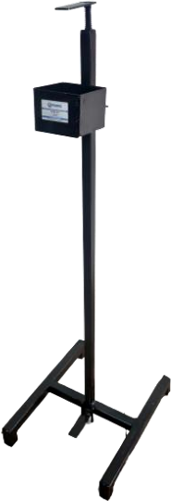
  - Most demandable product
  - Color : Paint/Powder Coated
  - Material : MS/Plastic

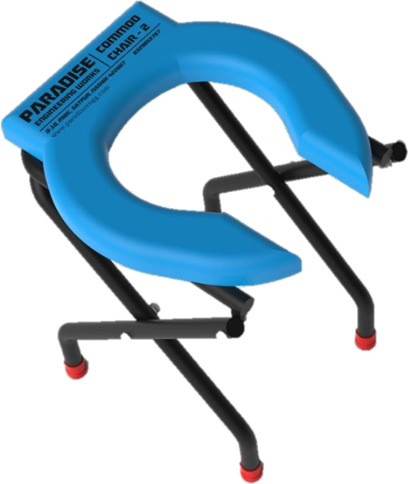
    - Commode Stool
    - Adjustable type.
    - Color : Paint/Powder Coated
    - Material : MS/SS304/Plastic

    - Sanitizer Dispenser
- Most demandable product
    - Commode Chair
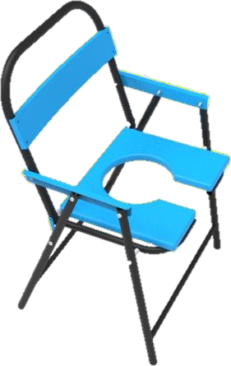
- Most demandable product
- Color : Paint/Powder Coated
- Material : SS304/MS/Plastic

  - Color : Paint/Powder Coated
  - Material : MS

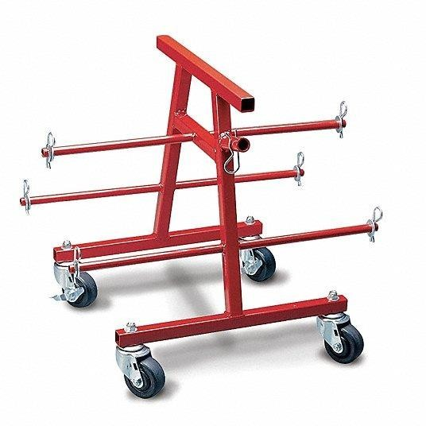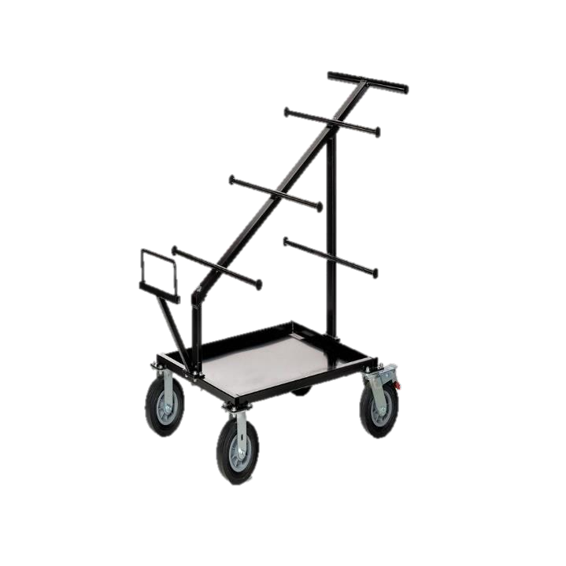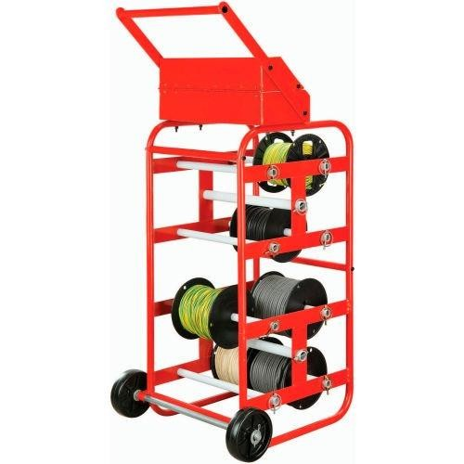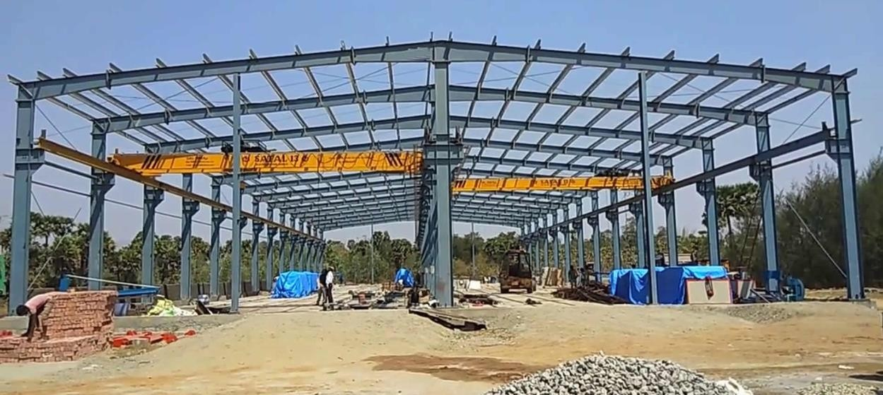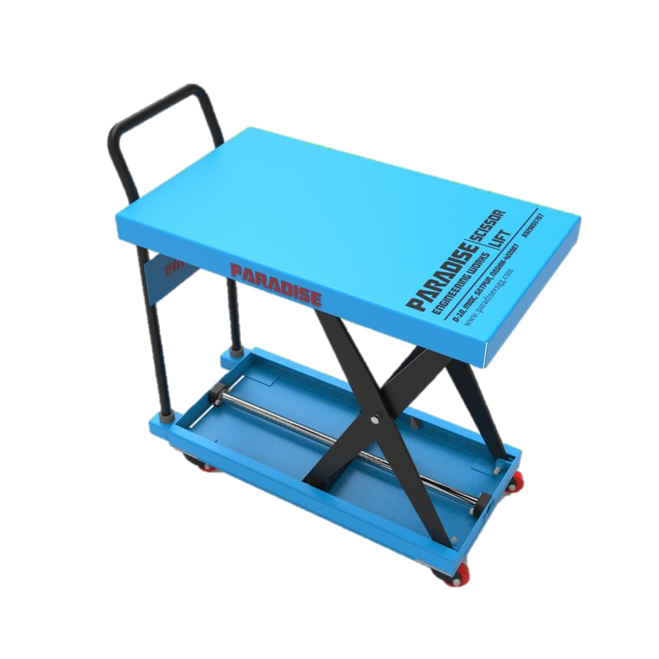

SCISSOR LIFT TABLE*
# Type :
      - Manual ( Lead Screw operated)
      - Hydraulic Operated
      - Electrical Operated

# Most Demandable Product 350 Kg Capacity

Industrial Shade fabrication Services

Product Specification
Model | Scissor Lift Table
HSN No. | 8427
Product Code | Mech- PSLM001 | Hydraulic- PSLH001 | Electrical-PSLE001
MOC | MS Powder Coated Finish Or Paint
Type | Manual Lead Screw operated)/ Hydraulic up-down/ Electric Operated
Available Capacity | 350 Kg | 500 Kgs | 750 Kgs* | 1000 Kgs | 1300 Kgs* | 1500 Kgs* | 2000 Kgs*
Some products are in development stage.*

Industrial Wire Roll Dispenser & Carrier trolleys

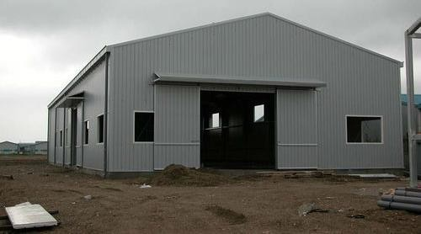

Industrial Shade fabrication Services
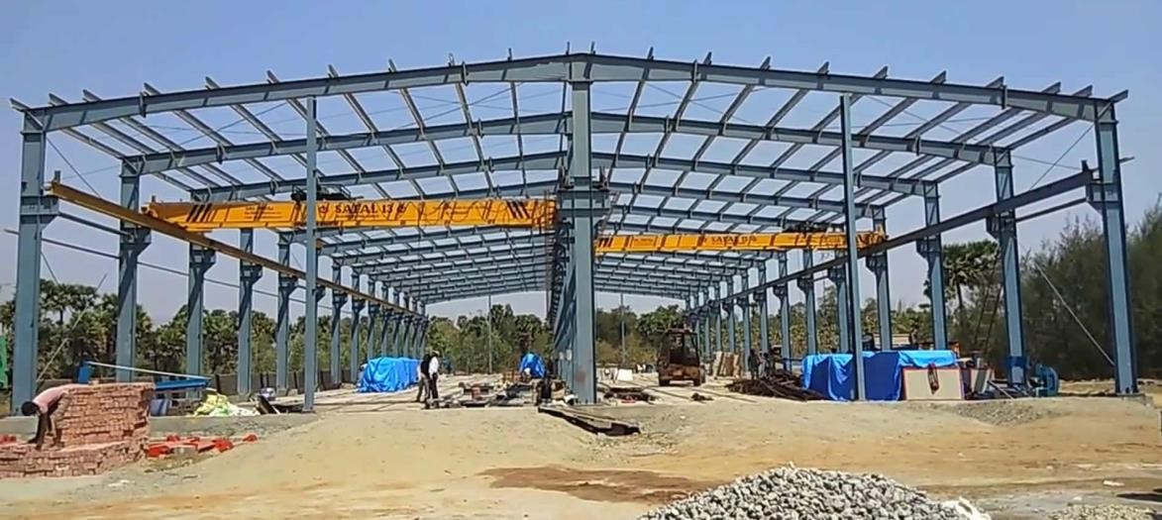

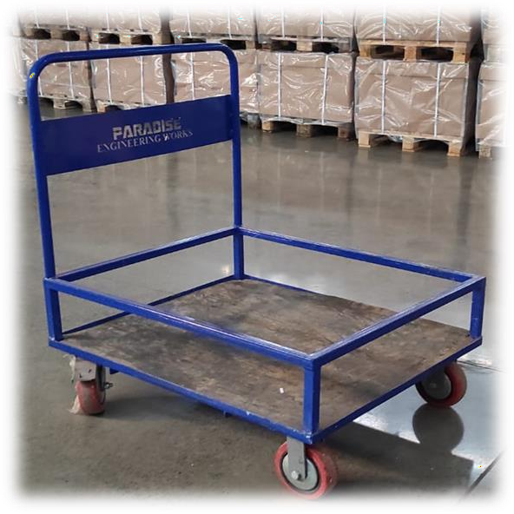
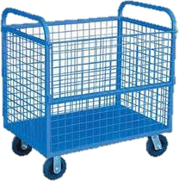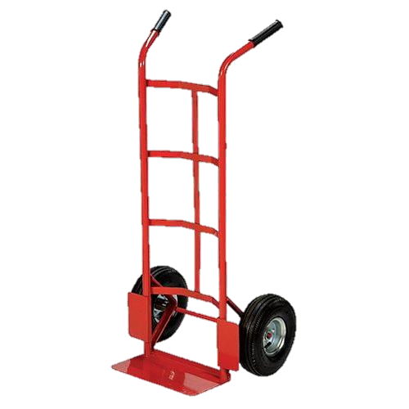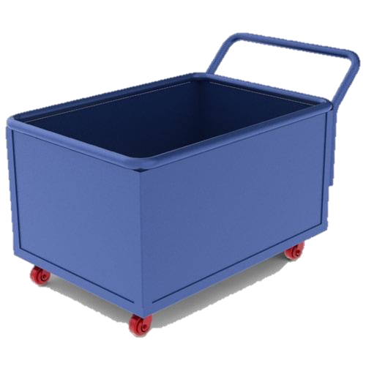

Material handling trolleys Scrap carrier trolley
Boxes & Drum Lifter –200 Kg Capacity
Material carrier-Fully Closed type

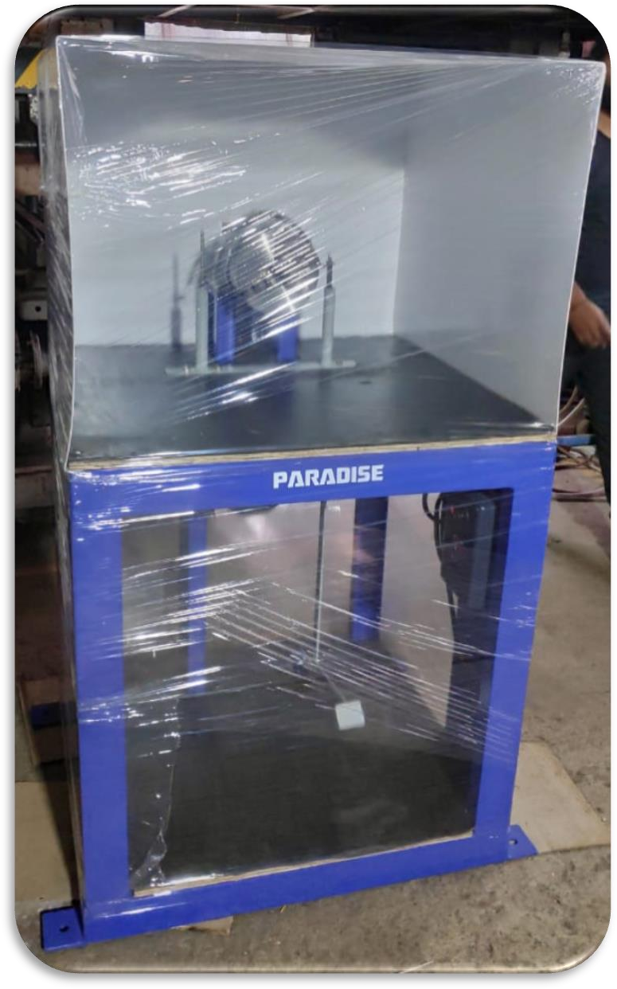
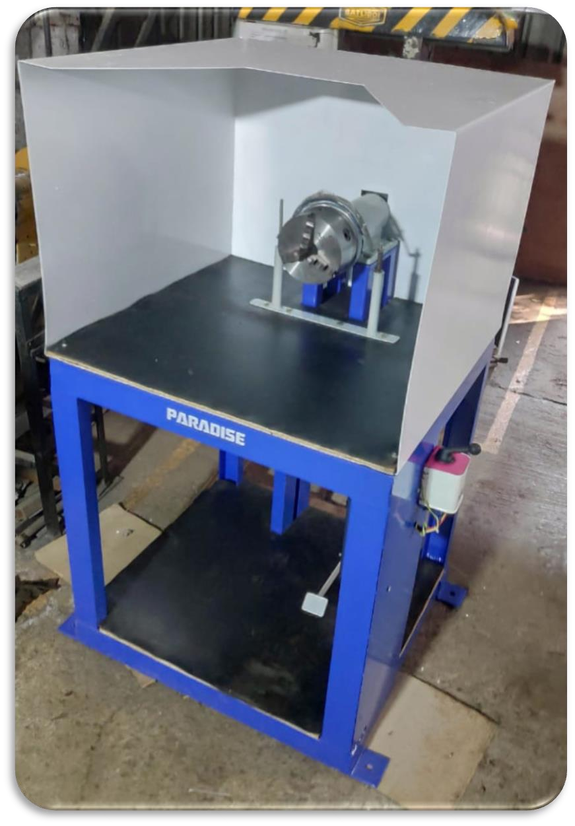


LAPPING MACHINE

# Motor :
1 HP, 3 Phase

# Chuck :
3 Jaw 160 mm Fine Arrangement , (SECO Made)

# Client :
Electronica Tungstan Pvt.Ltd Nashik.

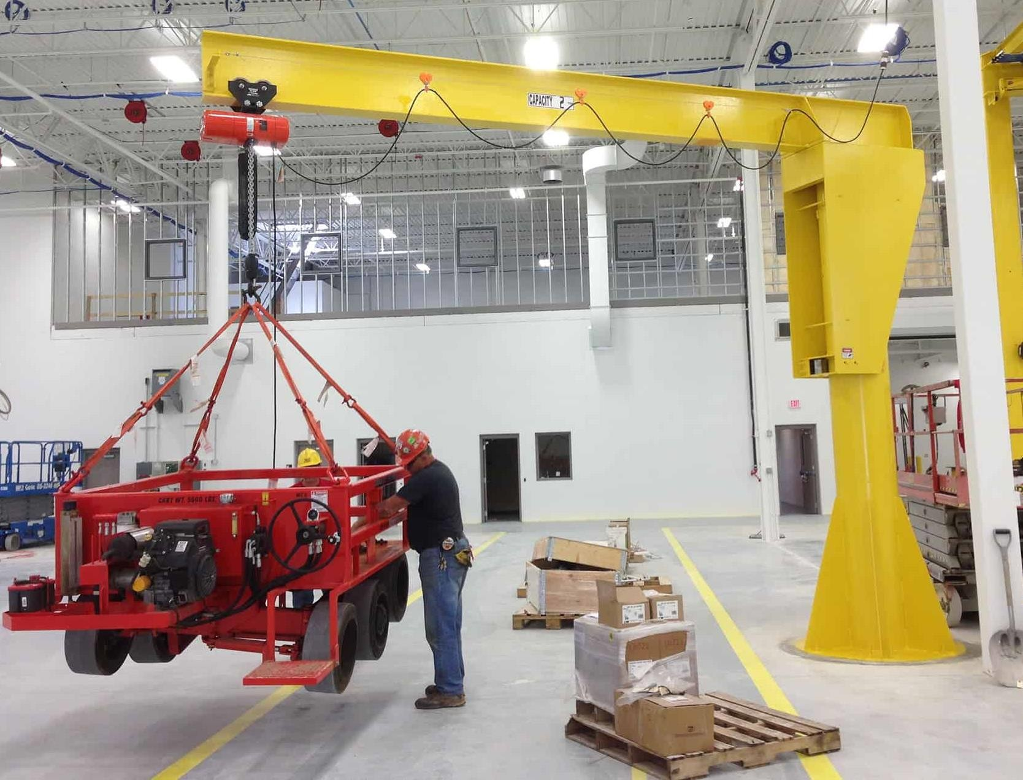
- Jib Crane manufacturing :

Free Standing Jib Crane

  - Foundationless Jib Crane

  - Mast Type Jib Crane :-
    - Full cantilever
    - Drop Cantilever

  - Wall/Column Mounted jib crane :-
    - Cantilever
    - Tie-Rod Supported



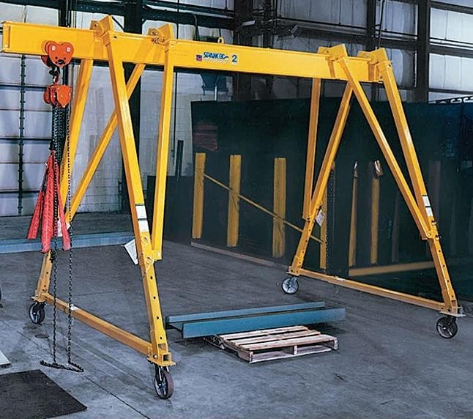2. Gantry Crane manufacturing :
B. Adjustable Gantry Crane Systems
- Portable Gantry Crane Systems
- Adjustable Gantry Crane Systems
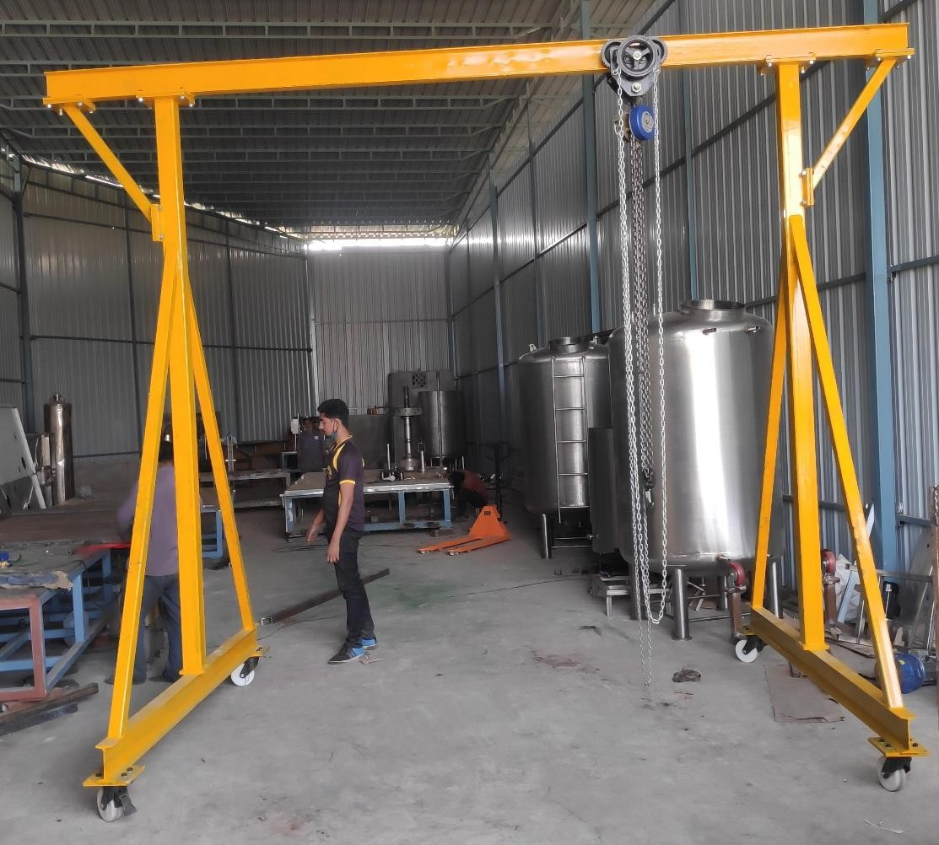
A. Portable Gantry Crane Systems
(Client – Shantanu Bottling Pvt.Ltd,Nashik.) (Client – Gujarat located.)

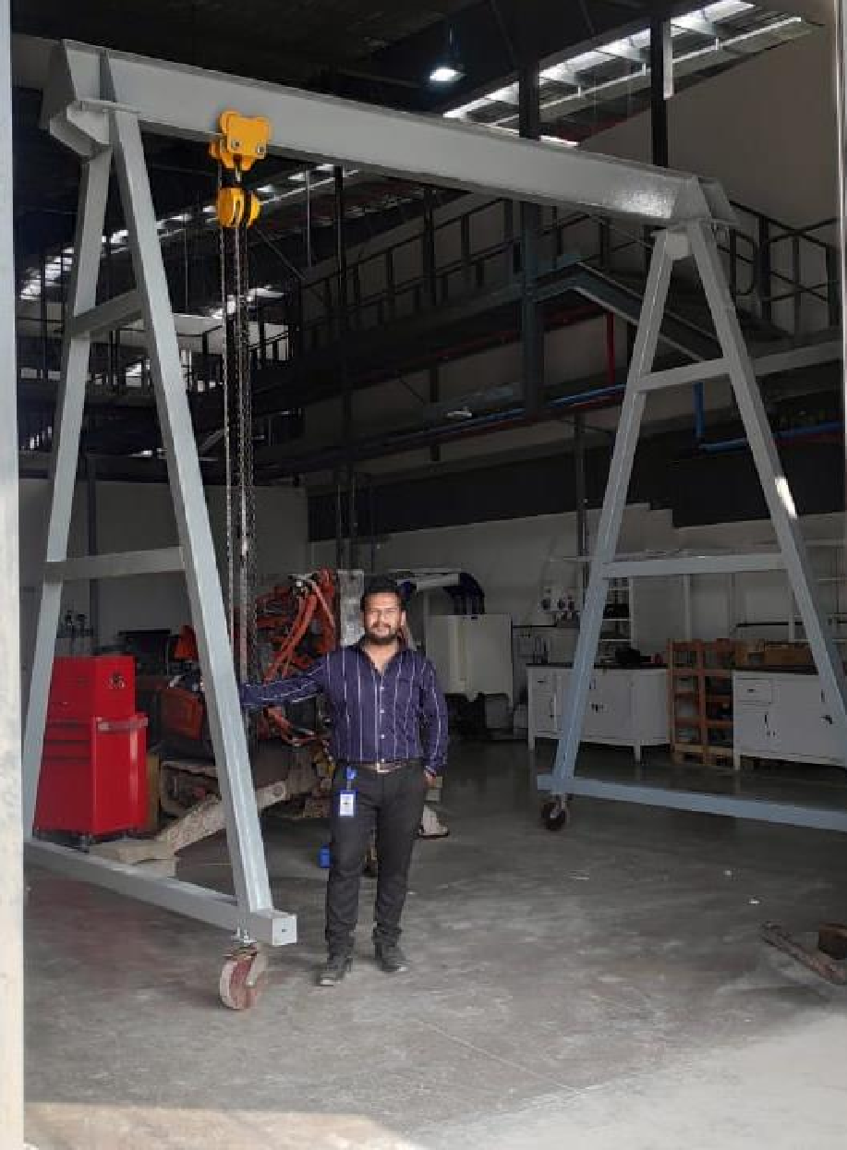

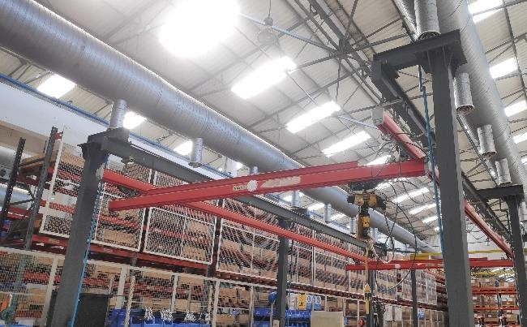
Product : Gantry Crane 3000HGC Capacity : 3 Ton
Hoist : Manual type.
(Client – Husqverna Group ,Nashik)

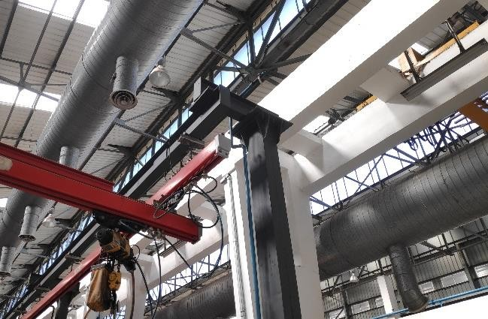

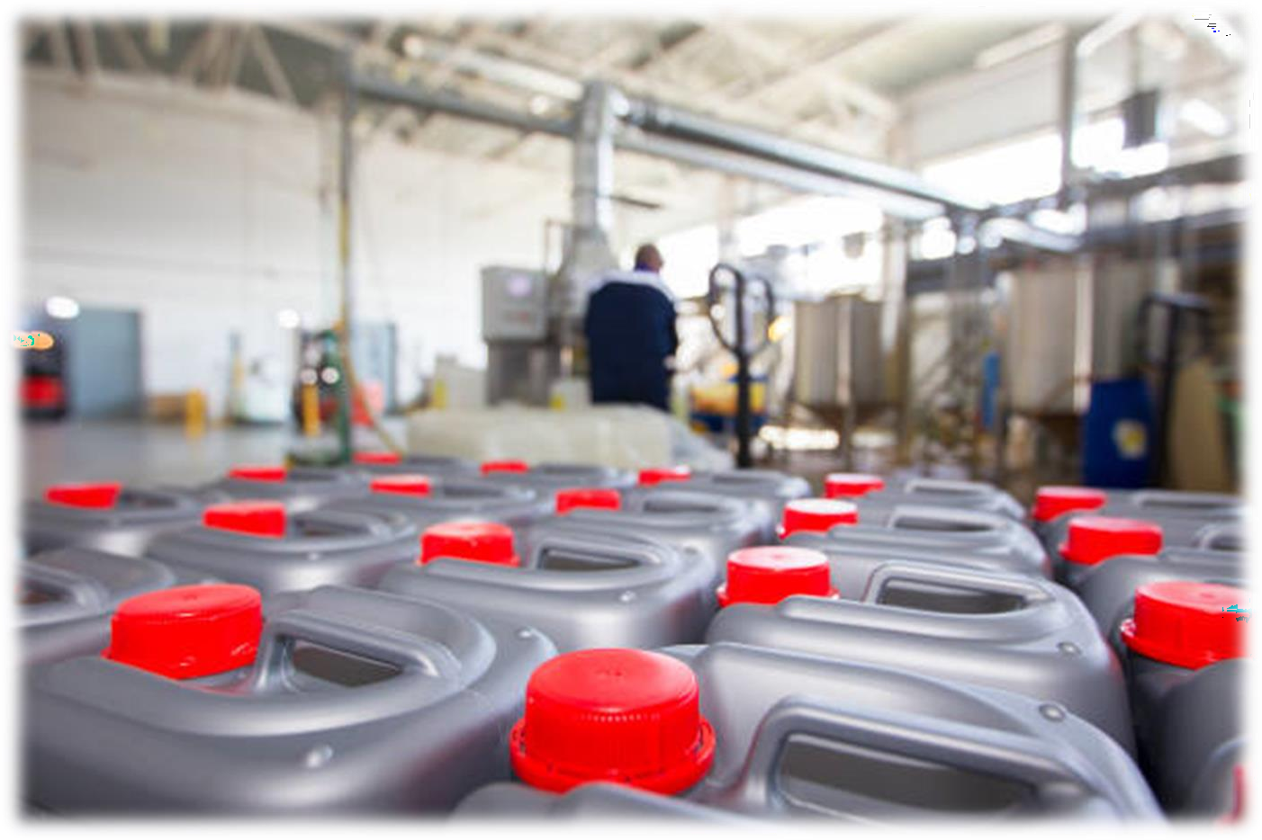
- We are Delivering Premium Quality of Bottles & Oil filling & Packaging facility from 1 Liter Bottle to 210 Liter Drum.
- 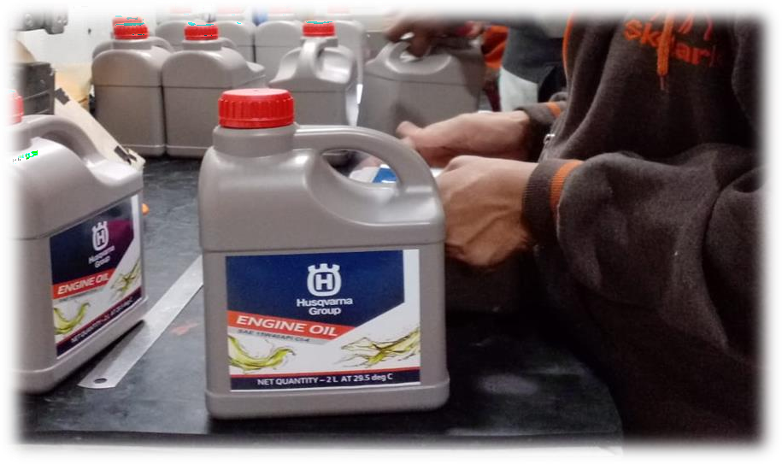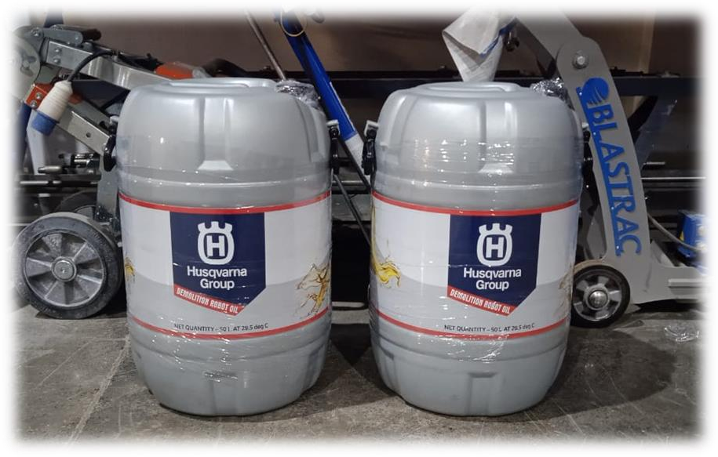We provide All Services like Brand Listing, Trademark registration ,Plastic Oil bottle Trading, Oil filling & Packaging Service Etc.



Factors responsible for our enormous success are as follows:
- In-depth industry knowledge.
- Timely completion of orders.
- Transparent business dealings.
- Qualified and trained team of professionals.
- Market leading prices.



BUSINNESS | DETAILS
COMPANY CEO | Mr.Shantaram S Kapadnis
COMPANY LOCATION | Plant-01 ,D-10,MIDC,Satpur,Near Santosh Hotel, Nashik.  Plant-02 ,Bajarang Nagar, near Annacha Mala, Ambad ,Nashik-422007
COMPANY E-MAIL ID | info@paradiseengg.com Paradiseengg.2013@gmail.com
TOTAL NO. OF EMPLOYEE | 15
ENGINEERS & DEDICATED TEAM | 8
YEAR OF ESTABLISHMENT | 13 JANUARY, 2013
OWNERSHIP TYPE | Sole proprietorship
ANNUAL TURNOVER | Upto 80 Lakhs.
PLANT MANAGER | Mr.Chetan S. Kapadnis
CONTACT | +91-8329855767 / 7350856794
E-MAIL ID | chetank@paradiseengg.com
COMPANY WEBSITE | www.paradiseengg.com


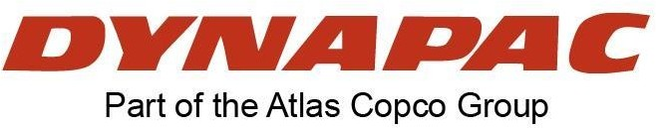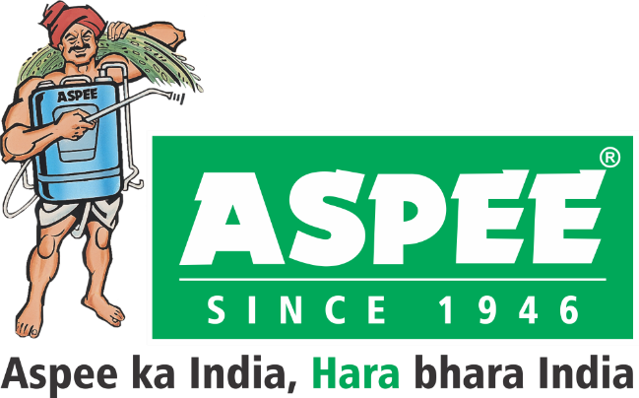
- Construction Tool equipment Services:
- Electrical panel & material handling Equipment:
Virtuoso Optoelectronics Pvt. Ltd
- Agricultural Equipment manufacturing

We are happy to serve you the best quality Product in the Industry!!

